# **From electricity to bits Practice**

The Apple iPhone includes a settings menu where you can toggle various accessibility options on or off:

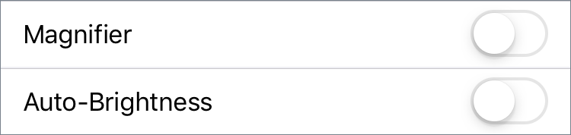

**What is the minimum number of bits that can represent those 2 options?**

Alejandra is putting together a simple computing machine using 2 wires.

Each wire can be considered either "on" or "off" depending on its voltage, thanks to the transistors.



**How many bits of information can those wires represent?**

**Which of these best describe what a binary digit can store?**

Choose 1 answer:

* A binary digit can store a series of two single-digit values, such as [4, 8].
* A binary digit can store one of two values, 0 or 1.
* A binary digit can store one of the values from 0 - 9.
* A binary digit can store a series of two 0/1 values, such as [1, 1]

**An Apple Mac computer includes a status menu with various indicators:**

**Screenshot of Mac status menu, with bluetooth icon, wireless icon, battery icon, and current day and time.**

**Which of the indicators could represent a single bit of information?**

**👁️Note that there are 2 answers to this question.**

Choose 2 answers:

* The current time of day
* The day of the week
* The bluetooth status (disconnected/connected)
* The wireless connectivity level (0-4)
* The charge level of the battery (0-100%)
* The source of power (battery/adapter)